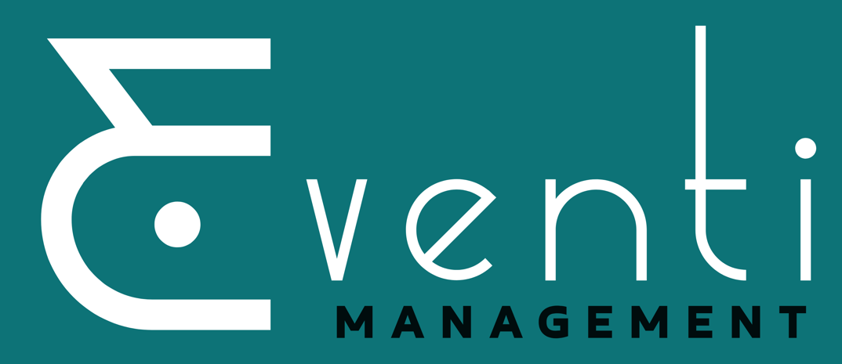
Eventi Management
Universal Media Statement
Eventi Management through its policy, Safeguarding Children and Vulnerable Persons, is committed to setting standards for the safeguarding of children and vulnerable persons participating in and contributing to Eventi Management’s festivals.
Eventi Management creates, disseminates, and reports its festivals through varied media.
Photographs, film, and sound recordings are pursued for the purposes of creative programming, programme development and promotion, and posterity. Written evaluations and testimonials are gathered for the purposes of creative programming, reportage, fundraising and promotion, and posterity.
All participating in Eventi Management's festivals understand there will be no financial remuneration for their participation in Eventi Management's productions either for initial or subsequent playback.
Signed Universal Media Releases will be sought from all registered participants in Eventi Management’s summerSING! Festival. It is not practical, however, for us to pursue members of the public and general audience for their individual permissions and releases. Neither it is possible for us to control the use of cameras, video cameras and smartphones by members of the general public and audience.
Concerns about intrusive or inappropriate taking of photographs, recorded images or sound recordings by members of the public and general audience should be reported directly to the Designated Liaison Panel as listed below:
Designated Liaison Panel
Sinéad Dunphy (Managing Director), Mary Watson (Festival Manager).
A full copy of our Children and Vulnerable Persons Safeguarding Policy and Procedures can be found on www.summersinge.ie/safeguarding
Eventi Management | 12 Mulgrave Road, Shandon, Cork | www.eventi.ie | www.summersing.ie | +353 (0)21 4553095 Eventi Management OD Ltd | Registered in Ireland | Company Number: 657488 | Director: Sinéad Dunphy

